Sample questions upload file

Note that whatever text is outside of a table is not processed in import, so you may freely use it as comments, as is done in the sample document. You may also use page breaks if you wish.
Each question is a separate table, with 2 columns : the first contains field identifiers, the second contains field values.
The first column depends on the settings of the thematic base. If you have a thematic base where the questions have a level, an explanation, a score .... then you will have to add these informations in the left column and fill it in. It also contains an indicator of right or wrong answers.
Left column:
item (number identifying the question that will be used for updating),
domain, tags (list of tags separated by a comma),
title, question (question statement), true or false (for answers),
explanation, rule
level (integer between 1 and 5), score (integer), time (in s), essential (yes/no), sequence (letter-number like A-1)
type which can take the following values depending on the type of questions :
1. single
2. multiple
3. text
4. sort
5. match
6. true false
7. fill
8. select
9. free
10. classification
11. soft skills single
12. soft skills multiple
Notice:
- Questions with an image to be clicked must be created with the web interface in order to define the valid zone with the mouse.
- Score per answer :
If the option (score per answer) is set for the base, you can specify the score per answer for question which type is 1-2-6-7-8.
In this case, the score can be specified between square brackets at the end of the answer.
Example for the question 1
1600 meters [5]
250 meters [-1]

1. A question with a single correct answer : type 'single'
In this question, the user is asked to select the answer that is correct.
item | 1
title | Antarctica's ice cover
domain | geography
question | What is the average thickness of the ice cover in Antarctica?
type | single
level | 4
essential | yes
true | 1600 meters
false | 250 meters
false | 650 meters
false | 1200 meters
explain | About 98% of Antarctica is covered by ice that averages 1.6 km in thickness, which extends to all but the northernmost reaches of the Antarctic Peninsula.
rule | Antarctica is Earth's southernmost continent, containing the geographic South Pole. It is situated in the Antarctic region of the Southern Hemisphere, almost entirely south of the Antarctic Circle, and is surrounded by the Southern Ocean. At 14,000,000 square kilometres (5,400,000 square miles), it is the fifth-largest continent in area after Asia, Africa, North America, and South America. For comparison, Antarctica is nearly twice the size of Australia. About 98% of Antarctica is covered by ice that averages 1.6km in thickness, which extends to all but the northernmost reaches of the Antarctic Peninsula.  Antarctica, on average, is the coldest, driest, and windiest continent, and has the highest average elevation of all the continents.

2. A question with multiple correct answers (and images) : type 'multiple'
In this question, the user is asked to select all correct answers, then validate
item | 2
title | Exploration of Antarctica
domain | Explorers
question | Which of these explorers ventured in Antarctica ?
type | multiple
level | 3
true | 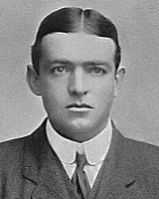Ernest Shackleton
true | 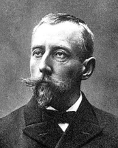Roald Amundsen
true | 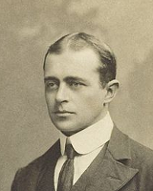Robert Falcon Scott
false | 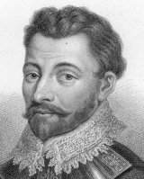Francis Drake
false | 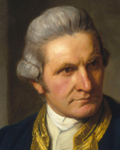James Cook
explain | Shackleton, Amundsen and Scott are the most famous explorers of the South Pole, in the early 20th century. James Cook and Francis Drake are great explorers too, but in earlier times.
rule | During the Nimrod Expedition led by Ernest Shackleton in 1907, parties led by Edgeworth David became the first to climb Mount Erebus and to reach the South Magnetic Pole. Douglas Mawson, who assumed the leadership of the Magnetic Pole party on their perilous return, went on to lead several expeditions until retiring in 1931.[31] In addition, Shackleton himself and three other members of his expedition made several firsts in December 1908 – February 1909: they were the first humans to traverse the Ross Ice Shelf, the first to traverse the Transantarctic Mountains (via the Beardmore Glacier), and the first to set foot on the South Polar Plateau. An expedition led by Norwegian polar explorer Roald Amundsen from the ship Fram became the first to reach the geographic South Pole on 14 December 1911, using a route from the Bay of Whales and up the Axel Heiberg Glacier.[32] One month later, the doomed Scott Expedition reached the pole.

3. A question with an answer to be entered as text : type 'text'
In this question, the user is to enter the correct answer using the keyboard. Note that several correct answers may be accepted, they are separated by commas in the true field.
item | 3
title | The Antarctic Treaty
domain | Geography
question | 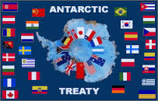  Antarctica's status is regulated by the Antarctic Treaty.  What year was this treaty signed ?
type | text
level | 5
true | 1959, 59
explain | The Antarctic Treaty was signed in 1959
rule | Antarctica's status is regulated by the 1959 Antarctic Treaty and other related agreements, collectively called the Antarctic Treaty System. Antarctica is defined as all land and ice shelves south of 60° S for the purposes of the Treaty System. The treaty was signed by twelve countries including the Soviet Union (and later Russia), the United Kingdom, Argentina, Chile, Australia, and the United States.[82] It set aside Antarctica as a scientific preserve, established freedom of scientific investigation and environmental protection, and banned military activity on Antarctica. This was the first arms control agreement established during the Cold War.

4. A question with ordering : type 'sort'
In this question, the user will be asked to order continents by size
item | 4
title | The size of continents
domain | Geography
question | Order the list of continents, with the largest coming first
type | sort
level | 3
true | Asia
true | Africa
true | North America
true | South America
true | Antarctica
explain | Antarctica is the smaller one in the list, but is still larger than Europe and Australia.
rule | At 14,000,000 square kilometres (5,400,000 square miles), Antarctica is the fifth-largest continent in area after Asia, Africa, North America, and South America. For comparison, Antarctica is nearly twice the size of Australia.

5. A question with matching : type 'match'
In this question, the user will be asked to match items placed in the right column with items on the left column. Answer item number 1 is in the left column, answer item 2 is in the right column and matches the first one, and so on. All answers must be 'true'.

Item | 5
title | Name the explorers
domain | Explorers
question | Match each explorer with his name
type | match
level | 3
true
true | Ernest Shackleton
true
true | Roald Amundsen
true
true | Robert Falcon Scott
explain | Shackleton, Amundsen and Scott are the most famous explorers of the South Pole, in the early 20th century.
rule | During the Nimrod Expedition led by Ernest Shackleton in 1907, parties led by Edgeworth David became the first to climb Mount Erebus and to reach the South Magnetic Pole. Douglas Mawson, who assumed the leadership of the Magnetic Pole party on their perilous return, went on to lead several expeditions until retiring in 1931.[31] In addition, Shackleton himself and three other members of his expedition made several firsts in December 1908 – February 1909: they were the first humans to traverse the Ross Ice Shelf, the first to traverse the Transantarctic Mountains (via the Beardmore Glacier), and the first to set foot on the South Polar Plateau. An expedition led by Norwegian polar explorer Roald Amundsen from the ship Fram became the first to reach the geographic South Pole on 14 December 1911, using a route from the Bay of Whales and up the Axel Heiberg Glacier.[32] One month later, the doomed Scott Expedition reached the pole.

6. A true false question : type 'true false'

item | 6
title | Antarctic flora
domain | Geography
question | There are no plants in Antarctica.
type | True false
level | 3
true | False
false | True
explain | 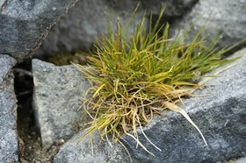
rule | https://en.wikipedia.org/wiki/Antarctic_flora  The continent of Antarctica itself has been too cold and dry to support virtually any vascular plants for millions of years. The chilling temperature, lack of sunlight, little rainfall, inferior soil quality and lack of moisture account, due to the inability of the plants to absorb water available in the form of ice, for scanty vegetation. Its extant flora presently consists of around 250 lichens, 100 mosses, 25-30 liverworts, and around 700 terrestrial and aquatic algal species. Two flowering plants, Deschampsia antarctica (Antarctic hair grass) and Colobanthus quitensis (Antarctic pearlwort), are found on the northern and western parts of the Antarctic Peninsula. Species of moss endemic to Antarctica include Grimmia antarctici, Schistidium antarctici, and Sarconeurum glaciale

7. A question with blancks : type 'fill'
In this question, the user will be asked to fill blanks in the given text. Blanks are identified by 4 underscore characters.
item | 7
title | Biodiversity in Antarctica
domain | Geography
question | Complete the text on animals in Antarctica  The snow ____ is one of only three birds that breed exclusively in Antarctica.The ____ penguin is the only penguin that breeds during the winter in Antarctica
type | fill
level | 3
true | petrel
true | emperor
explain | 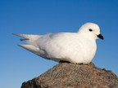  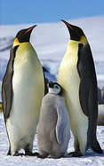
rule | https://en.wikipedia.org/wiki/Antarctica#Animals  Animals  Few terrestrial vertebrates live in Antarctica. Invertebrate life includes microscopic mites like the Alaskozetes antarcticus, lice, nematodes, tardigrades, rotifers, krill and springtails. The flightless midge Belgica antarctica, up to 6 mm (1⁄4 in) in size, is the largest purely terrestrial animal in Antarctica. The snow petrel is one of only three birds that breed exclusively in Antarctica.  Some species of marine animals exist and rely, directly or indirectly, on the phytoplankton. Antarctic sea life includes penguins, blue whales, orcas, colossal squids and fur seals. The emperor penguin is the only penguin that breeds during the winter in Antarctica, while the Adélie penguin breeds farther south than any other penguin. The southern rockhopper penguin has distinctive feathers around the eyes, giving the appearance of elaborate eyelashes. King penguins, chinstrap penguins, and gentoo penguins also breed in the Antarctic.  8.

8. A question with selection : type "select"
In this question, the user will have to complete the blanks by choosing a proposal among those presented in the drop-down list. Expected responses are defined in the true field and are separated by commas. Note that the correct answer is preceded by a> sign.
Item | 8
titre | Balloon expedition
domaine | Explorers
question | After leading three polar expeditions:  • The expedition of ____, 1897-1899  • The Northwest Passage, 1903-1906  • The expedition to the South Pole, 1910-1912  Roald Amundsen reached the North Pole in 1926 in ____
type | select
niveau | 3
vrai | La Nina, La Pinta, La Banquise, >La Belgica
vrai | boat, > airshift , horse
explication
règle

9. A question with free answer: type 'free'
For this question, the user is free to answer an open question.
Note that no answer true is required. The correction of this type of question will be deferred .
Item | 9
title | Exploration of Africa
domain | Geography
question | What do you know about the exploration of Africa in the 19th century ?
type | free
level | 3
explain | In the mid-19th century, Protestant missions were carrying on active missionary work on the Guinea coast, in South Africa and in the Zanzibar dominions. Missionaries visited little-known regions and peoples, and in many instances became explorers and pioneers of trade and empire. David Livingstone, a Scottish missionary, had been engaged since 1840 in work north of the Orange River. In 1849, Livingstone crossed the Kalahari Desert from south to north and reached Lake Ngami. Between 1851 and 1856, he traversed the continent from west to east, discovering the great waterways of the upper Zambezi River. In November 1855, Livingstone became the first European to see the famous Victoria Falls, named after the Queen of the United Kingdom. From 1858 to 1864, the lower Zambezi, the Shire River and Lake Nyasa were explored by Livingstone. Nyasa had been first reached by the confidential slave of António da Silva Porto, a Portuguese trader established at Bié in Angola, who crossed Africa during 1853–1856 from Benguella to the mouth of the Rovuma. A prime goal for explorers was to locate the source of the River Nile. Expeditions by Burton and Speke (1857–1858) and Speke and Grant (1863) located Lake Tanganyika and Lake Victoria. It was eventually proved to be the latter from which the Nile flowed.  Henry Morton Stanley, who had in 1871 succeeded in finding and succouring Livingstone (originating the famous line "Dr. Livingstone, I presume"), started again for Zanzibar in 1874. In one of the most memorable of all exploring expeditions in Africa, Stanley circumnavigated Victoria Nyanza (Lake Victoria) and Lake Tanganyika. Striking farther inland to the Lualaba, he followed that river down to the Atlantic Ocean—which he reached in August 1877—and proved it to be the Congo.  In 1895, the British South Africa Company hired the American scout Frederick Russell Burnham to look for minerals and ways to improve river navigation in the central and southern Africa region. Burnham oversaw and led the Northern Territories British South Africa Exploration Company expedition that first established that major copper deposits existed north of the Zambezi in North-Eastern Rhodesia. Along the Kafue River, Burnham saw many similarities to copper deposits he had worked in the United States, and he encountered native peoples wearing copper bracelets.[7] Copper rapidly became the primary export of Central Africa and it remains essential to the economy even today.
rule | https://en.wikipedia.org/wiki/Exploration_of_Africa#The_19th_century

10. A question « classification »
For this question, you must define catégories and elements to classify in these categories.
The syntax is : categorie :: element
You can create an empty category : categorie ::
You can create element without category : :: element
item | 10
titre | Classify animals in their category
domain | Nature
question | Drag and drop animals in their category if it is possible.
type | classification
level | 3
true | 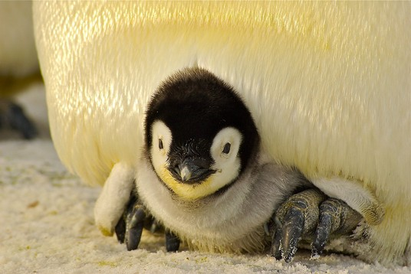  Birds :: penguin
true | 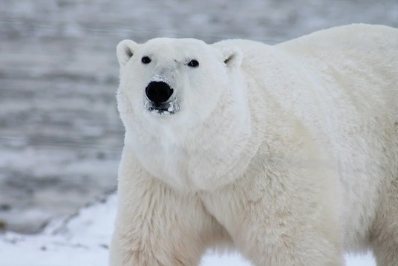  Mammals ::
true | :: krill
true | Fish ::

11. A question « soft skills » single
Dans cette question, une seule réponse peut être sélectionnée.
item | 11
title | Type of explorers
domain | Explorers
question | You are an astrobiologist and you are invited to a wintering in Antarctica, what is your reaction ?
type | Soft skills single
level | 3
true | [analysis, organization] A year with ten strangers, 3 months of darkness, -80°C , never !
true | [impulsive, open, motivated] Great, an adventure that will get me out of my daily routine, when do we leave?
true | [reasonable, adaptability] Why not, learning sometimes requires certain sacrifices. I'm gonna think about it.

12. A question « soft skills multiple »
In this soft skills question, several answers can be selected. They will bring into the analysis all the tags associated with them.
item | 12
title | Temperature and spirit
domain | Explorers
question | You are an astrobiologist and we suggest a wintering in Antarctica, what thoughts come to your mind ?
type | Soft skills multiple
level | 3
true | [negotiator] I will ask for compensation.
true | [team spirit] I like to work in a team.
true | [analysis, structure] I hate the cold, the night and the discomfort.
true | [adventurer, adaptability] I like to open my horizon.
true | [creativity] I'm going to make discoveries.

A question with some text formatting
In this question, the user will be asked select many answers according to the question asked.
item | 13
title | Roald Amundsen
domain | Explorers
question | After leading three polar expeditions :  - The Belgica expedition, 1897-1899  - The Northwest Passage, 1903-1906  - The South Pole expedition, 1910-1912  Roald Amundsen reached the North Pole, in 1926, traveling in a ____.
type | fill
level | 3
true | Airship, balloon, blimp, dirigible
explain | In 1926, he was the first expedition leader for the air expedition to the North Pole.  Note that you can also include programming langage snippets, by using a courier font.
rule | https://en.wikipedia.org/wiki/Roald_Amundsen  - Roald Engelbregt Gravning Amundsen ; 16 July 1872 – c. 18 June 1928) was a Norwegian explorer of polar regions. He led the Antarctic expedition of 1910–12 which was the first to reach the South Pole, on 14 December 1911. In 1926, he was the first expedition leader for the air expedition to the North Pole.  - Amundsen is recognized as the first person, without dispute, as having reached both poles. He is also known as having the first expedition to traverse the (1903–06) in the Arctic.  - In June 1928, while taking part in a rescue mission for the airship Italia, the plane he was in disappeared. Amundsen was a keyNorthwest Passage expedition leader during the Heroic Age of Antarctic Exploration, in the class of Douglas Mawson, Robert Falcon Scott, and Ernest Shackleton.

